Question # 2: 5 Marks

A PL/SQL is needed to calculate annual raises and update employee salary amounts recorded in the EMP table. Create a block that addresses the requirements below. Note that all salaries in EMP table are recorded as monthly amounts. Display the calculated salaries for verification before including the update action.
- Calculate 5% annual raises for all employees except AD_VP.
- If the 5% totals to more than 2000, cap the raise to 2000.
- Update the salary for each employee in the table.
- For each employee display the current annual salary, raise, and proposed new annual salary.
- At the end, show the total amount of salary increase.

NOTE: Create the table EMP as a copy of Employee table as follow:

Create table emp (empno, ename, sal,job)
As( select employee_id,first_name||' '||last_name,salary,job_id from employees)

@ First Row | @ last row
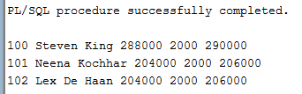 | 